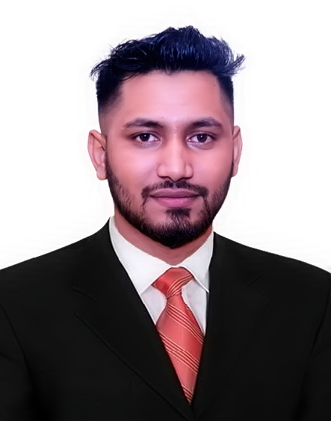
Resume
of
Mohammad Abbas Uddin

Mailing Address:
Kabir Telecom,
College Rode, Bibirhat, Fatickchari,
Chittagong.
Cell: +8801837-363738
E-mail: mdabbas268@gmail.com

OBJECTIVE | I have a great pleasure and keen interest to join in a well reputed and dynamic organization to serve the nation and to prove myself as an honest, eligible, dynamic and dexterous person.
ACADEMIC QUALIFIACTION | Title : Bachelor of Business Studies {B.B.S Degree(pass)}  Major : Accounting  Institution : Fatikchhari College, Fatikchhari, Chittagong  University : National University  Year of Passing : 2014  Result : Second Class  Title : Higher Secondary Certificate (HSC)  Group : Business Studies  Institute : Fatikchhari College, Fatikchhari , Chittagong  Board : Chittagong  Passing Year : 2011  Result : GPA-2.60 (Out of 5.00)  Title : Secondary School Certificate (SSC)  Group : Business Studies  Institute : Bhujpur National High School  Board : Chittagong  Passing Year : 2009  Result : GPA-3.19 (Out of 5.00)
SKILL | MS Word,  MS Excel,  MS PowerPoint,  Graphics Deign  Web Development  Facebook AD  SEO  Digital Marketing  Google reviews  Technical SEO Audit  Data Entry  Products Listing  Wordpress Installation  Email Marketing  Product Marketing  Adobe Photoshop
PERSONAL INFORMATION | And All Kinds of Software.  Full Name : Mohammad Abbas Uddin  Father’s Name : Mohammad Ahamad Kabir  Mother’s Name : Halima Begum  Permanent Address : Village: East Bhujpur, P.O- Bhujpur,  Upazilla- Fatikchhari, District- Chittagong.  Date of Birth : 14th Sep 1991.  Marital Status : Unmarried  Religion : Islam  Nationality : Bangladeshi (by birth)
SELF ASSESSMENT | - Excellent communication presentation skills.  - Team player who believes in knowledge sharing and collaboration.  - Self-motivated, confident, optimistic and willing to take challenge.  - Energetic, sincere, hardworking and friendly as a person.  - Ability to work within a team and individually.  - Cheerful and friendly.  - Strong desire for learning and honest life with dignity.  - Aspiration to build a carrier in showing superior performance.  - Strong desire to achieve result or goal.  - Ability to take responsibility.  - Over all most obedient.
LANGUAGE PROFICIENCY | English : Reading, Writing, Listening and Speaking.  Bengali : Reading, Writing, Listening and Speaking.
INTEREST | Reading story books, watching TV, traveling and Browsing the internet to discovering something new.
Declaration: | I hereby certify that the above mentioned information are true and correct to the best of my knowledge and belief.

Sincerely Yours

Mohammad Abbas Uddin
Date:

